**XML Assertion in JMeter:**

Test plan –right click-add-thread-thread group

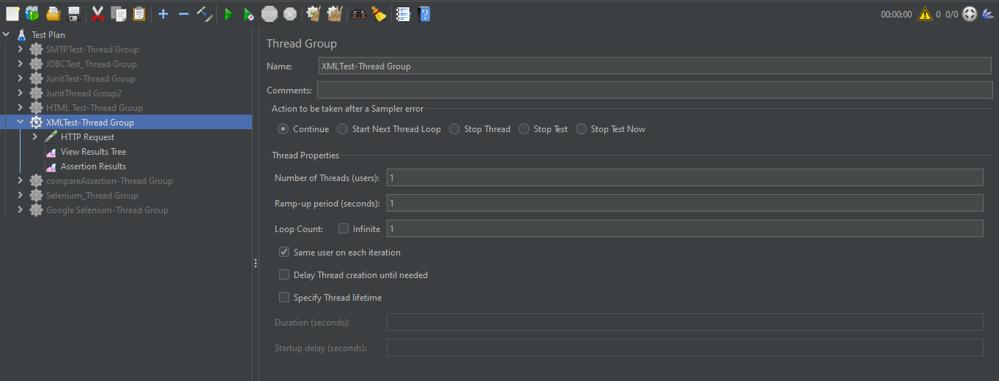

Thread group-right Click-add-sampler-http request.

In http request need to add protocol, server and path of the page.

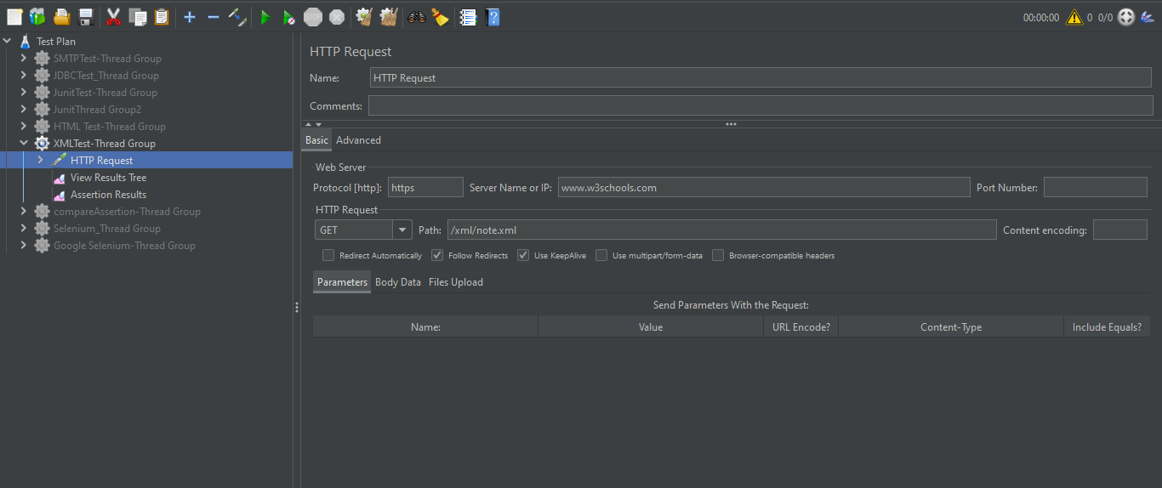

Thread group-right click-Add –listener-View result Tree.

Below we can see the Http request is success and the data is shown below.

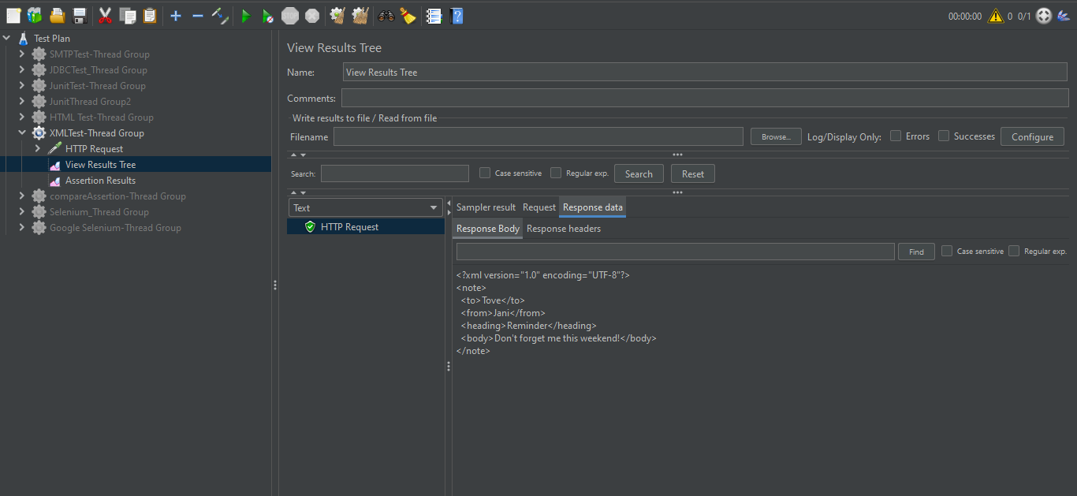

Right click on thread group-add-listener –assertion result.

